Guide to Order of genomic test in Vikmate done by Tine

1.Order from farmer

Farmer goes to VikMate (vikinggenetics.com) and uses his/her login.
If farmer is missing login contact Tine adviser.
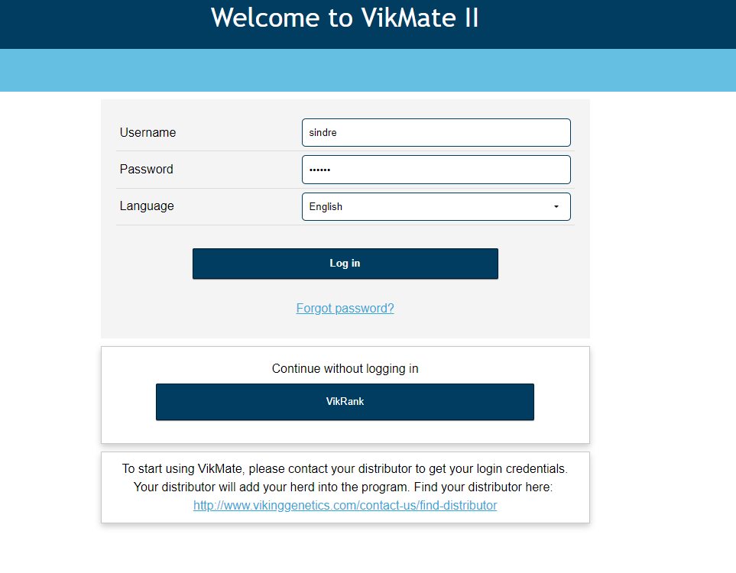
When farmer in in it looks like this:
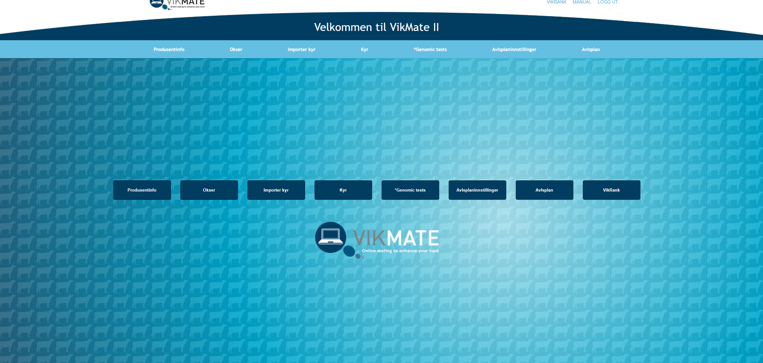
If farmer want to do a genomic test he goes into the genomic test tab. Then this window open.
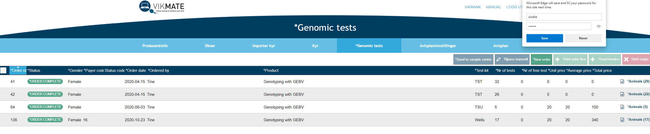
This is an overview of farmers orders. If farmer want to do a new order, he push new order.
This window come up

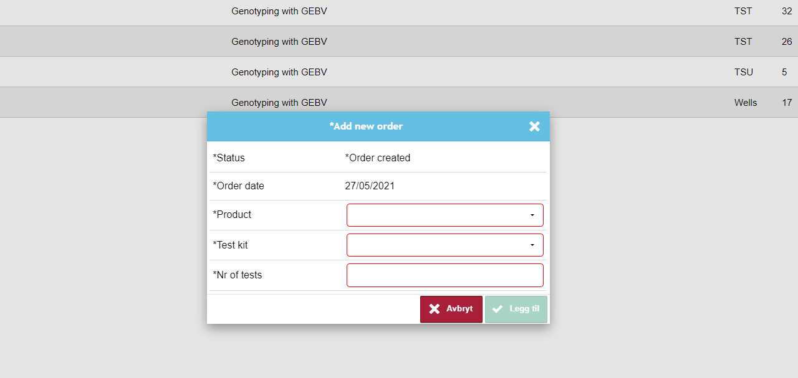

Farmer makes his order by fill out the fields. Then legg til and new order is created.
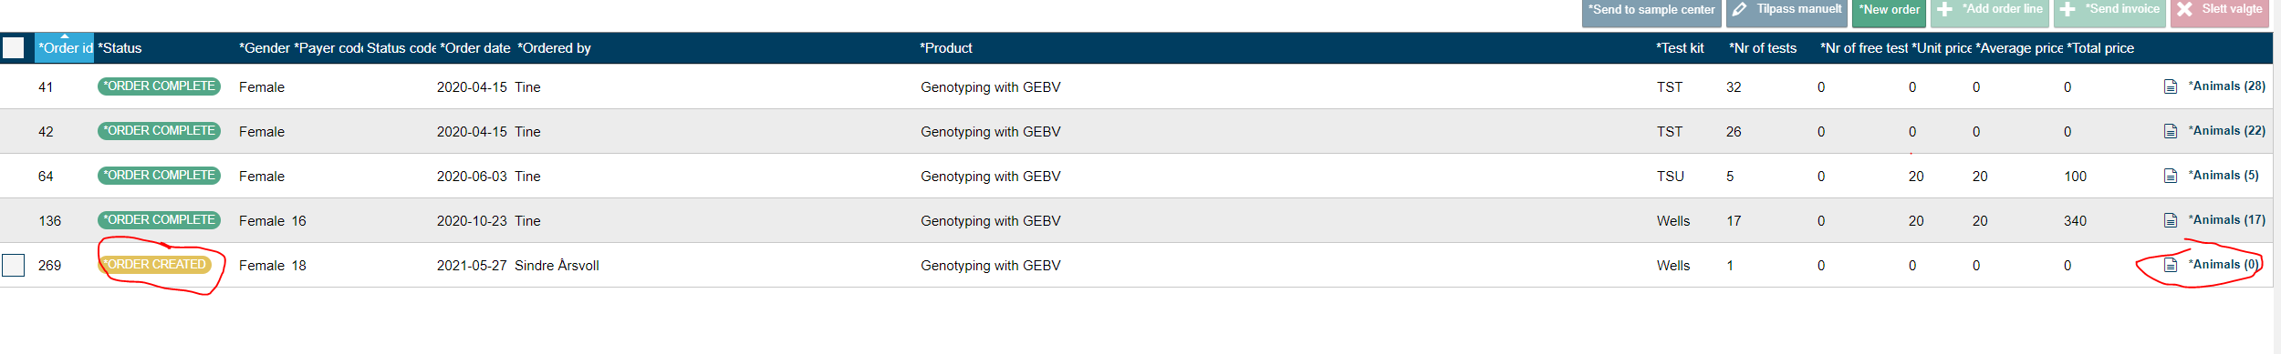
Push the animal field to open possible animals to genotype. The list with anmals open and you mark animals to the order and push the send to test button.
